Employee Information
Name
Title
Manager
Employee ID
Call Extension
Starting Date
Employee Email
Department
Workstation Location

- Read our blog post, which provides more information on each Checklist Item.
https://delinea.com/blog/it-offboarding-checklist-template

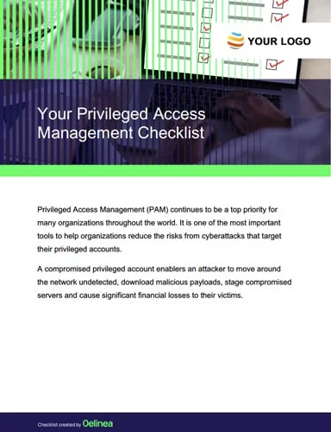
- FREE PAM CHECKLIST:
Need a step-by-step guide for planning your strategic journey to privileged access security? Start with our free, customizable PAM Checklist
https://delinea.com/resources/privileged-access-management-pam-checklist

Checklist Item |  | How is this service provided? |  |  | Status | Notes
 |  | Automatically | Manager Request Required | Employee Request required
Announce employee departures |  | x
Add your subtask |  | x
Add your subtask
Add your subtask
Revoke or restrict privileged account access |  | x
Add your subtask
Add your subtask
Add your subtask |  | x
Block remote access |  | x
Add your subtask |  | x
Add your subtask
Add your subtask
Change all passwords on shared accounts |  | x
Add your subtask |  | x
Add your subtask
Add your subtask
Cancel email access |  | x
Add your subtask |  | x
Add your subtask
Add your subtask
Check for telephone forwarding |  | x
Add your subtask |  | x
Add your subtask
Add your subtask
Checklist Item |  | How is this service provided? |  |  | Status | Notes
 |  | Automatically | Manager Request Required | Employee Request required
Remove mentions from internal documents |  | x
Add your subtask |  | x
Add your subtask
Add your subtask
Update physical access controls |  | x
Add your subtask |  | x
Add your subtask
Add your subtask
Collect company-owned devices |  | x
Add your subtask |  | x
Add your subtask
Add your subtask
Back up and secure critical files |  | x
Add your subtask |  | x
Add your subtask
Add your subtask
Create forensic computer images |  | x
Add your subtask |  | x
Add your subtask
Add your subtask
Perform real-time network monitoring |  | x
Add your subtask |  | x
Add your subtask
Add your subtask
Conduct a thorough exit process |  | x
Add your subtask |  | x
Add your subtask
Add your subtask

Bonus checklist for offboarding IT administrators
Checklist Item | How is this service provided? |  |  | Status | Notes
 | Automatically | Manager Request Required | Employee Request required
Transfer knowledge in advance | x
Add your subtask | x
Add your subtask
Add your subtask
Involve your legal team | x
Add your subtask | x
Add your subtask
Add your subtask

